Using the hybrid model exploration framework
Version: 1.0
Date: June 2021

Contents

What is a hybrid working model? 1
What problems are we looking to solve by using the hybrid model approach? 2
Using the hybrid model framework approach: 3
1. Engagement with managers and their teams 3
2. Information gathering 3
Preparation for the conversations 4
3. Documenting the ‘As-Is’ model 5
Step 1: Start with the contextual information you have gathered 5
Step 2: Draw out the next steps and areas of focus 6
Step 3: Use the contextual information and next steps to generate a short, compelling account of the main impact, tied to the actionable areas of focus. 6
Step 4: Update the sliders so that they reflect the key area that was discussed. 7
Step 5 – Create an overall summary of the ‘as-is’ model. 8
4. Exploration of future models – what comes next? 9

What is a hybrid working model?
A hybrid model combines remote and flexible working practices with office-based working.
Hybrid models should consider what work is done, where work is done, how work is done and who does the work. Exploring these areas will help determine the design of your future ways of working. No model is ever going to be perfect, but by considering a variety of factors you will be able to determine the best model for your teams.
Some elements of hybrid working are visible as they affect teams on a day-to-day basis. Some aspects are less visible, so we have a created a framework that helps teams to think about all the key elements of hybrid working.
The Hybrid model exploration framework is a conversation tool that has been developed to help teams explore and articulate what matters most. It can help to have consistent conversations about future ways of working across the diverse teams in your organisation.
The framework enables you to capture insights about the unique things that matter to teams, and to bring these insights together to help organisational leadership and decision makers explore how hybrid working can support their long-term goals.
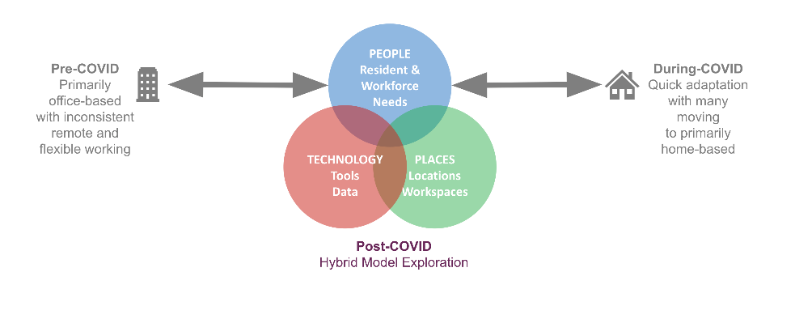

What problems are we looking to solve by using the hybrid model approach?
When doing research externally and within our own organisation, we found that:
- There are no ‘standards’ for exploring hybrid working models
- There is no common language for discussing hybrid working
- There are many different drivers for hybrid working models
So how do we make decisions about our working model in a post-Covid world?
Teams quickly shifted to working from home as a default in response to the pandemic. They have made adjustments in the short term, but we want to help organisations like ours think about:
- The trade-offs that come with changing their working model
- How to support teams to do their best work
- Developing ways of working that are sustainable
- Making decisions that reflect the evolving needs of their workforce
- How services could be delivered in the future

Using the hybrid model framework approach:
There are 4 main ‘phases’ to the hybrid model exploration approach.
- Engagement with managers and their teams
- Information gathering
- Documenting the ‘As-is’ model
- Exploration of future models
These phases are briefly described below:

1. Engagement with managers and their teams
The first step is to engage with leadership teams in your organisation to discuss how they would like to explore the framework in their teams.
Different parts of the organisation might want to approach this differently; some might want to have conversations with whole teams, others might want to have conversations with team leads and check back with team members as to whether this reflects the team. Setting up these conversations as a tool to help team members explore and articulate their needs is important to set the right expectations.

2. Information gathering
How you choose to work through the framework is entirely up to you. From left to right, top to bottom - choose the path enables you to have the right conversation for your team. Remember, it’s not a check-box exercise, it’s a starting point for an open conversation.
The framework focuses on the 9 key areas that were highlighted from our research, with each divided into 3 main groups:
- The service experience: This considers the user experience of the end users of services, the levels of flexibility within the service offer and how service performance is measured.
- The team experience: This considers the main people factors that can be affected by hybrid working, including talent attraction and retention, learning and development and engagement and connection across teams.
- Hybrid enablers: This considers the technology and data, workspaces and locations that are needed to support effective hybrid working.
There is some additional space on the framework to capture any other considerations such legal, obligatory requirements or maybe particular elements of your culture that you wish to retain. Conversations should be focused on the changes that have happened recently and the lessons that have been learned by teams throughout the Covid-19 response.
Remember, you’re looking to understand the impact of recent changes and whether short term responses are appropriate for long term change and the main priorities for defining future working models.
For each of the elements the framework includes some questions to help prompt the conversation. You don't need to stick to them and not all of them would be relevant depending on the type of service/team.
Once the team's voice has been captured, it's time to think about the impact that recent changes have had on things like the quality of service or the experience of your users. Those benefits and trade-offs are then discussed and captured as a group.
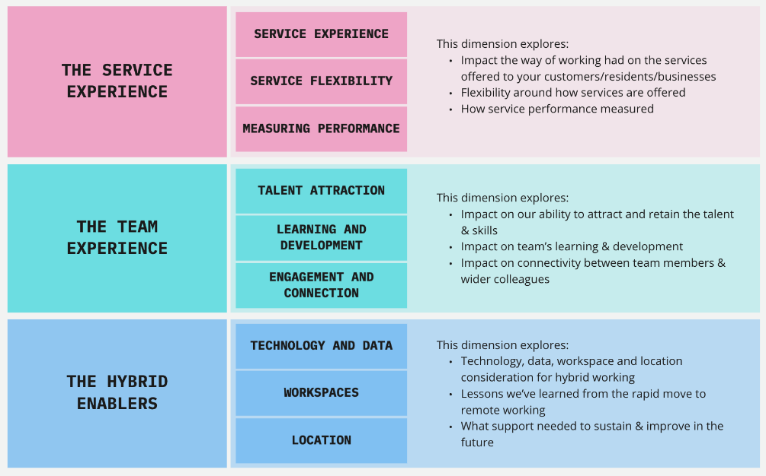

Preparation for the conversations
You can consider the following before having conversations using the framework:
- Determine at which level you would like to have these conversations and who you would need to include - you may choose to do this in large groups or in smaller one-to-ones.
- Some teams respond well to seeing what’s being captured and others don’t. We find that having a conversation feels more natural than thinking about which post-its/notes belong in which boxes. A co-facilitator can capture the notes in the background if you’d rather keep people focused on the conversation.
- Some boxes overlap and are related to each other – don’t worry too much about overlaps or duplications - just capture some notes and sort them later.
- At the least you will need a facilitator to host the session and keep the conversations focused and on track, and a scribe to capture notes. You might also consider having a facilitator that does not form part of that team to help people open up and say what they really think.
- The sessions do take a fair bit of time. Set aside at least 3 hours to work through the complete framework - with regular breaks to ensure that everyone stays engaged.
- Depending on the service complexity, you can work through the framework in stages, or all at once – whatever works best for your group.
- Consider how you will capture your notes and when you will need to play back what you’re hearing and to whom.

3. Documenting the ‘As-Is’ model
Once you have worked through the framework with your team, you’ll have a LOT of notes!
The next job is to work through the notes, section by section, to synthesise and summarise what was said against each area of the framework. We’ve developed a format for doing this which is shown below – but you may have different ideas about how you’d like to do this.
This step takes some time, but it’s important to create a record of your conversation that can be shared back with the team. This will be your ‘as-is’ summary and will form the basis of your conversations with the team around their future working model

Step 1: Start with the contextual information you have gathered
In the ‘contextual information’ area of the summary you can capture the things that ground your model in the reality of the team and how they work. This can include things around changing demand, service volumes, significant changes that were necessary due to the pandemic response, and other things that help to highlight how decisions were made and the impact that there has been on ways of working.
This contextual information is vital to support future decision-making. If decisions that were made were due to external factors that have now changed there may be a case for revisiting them. If demand or volumes are changing, then the teams ways of working may still be in flux.
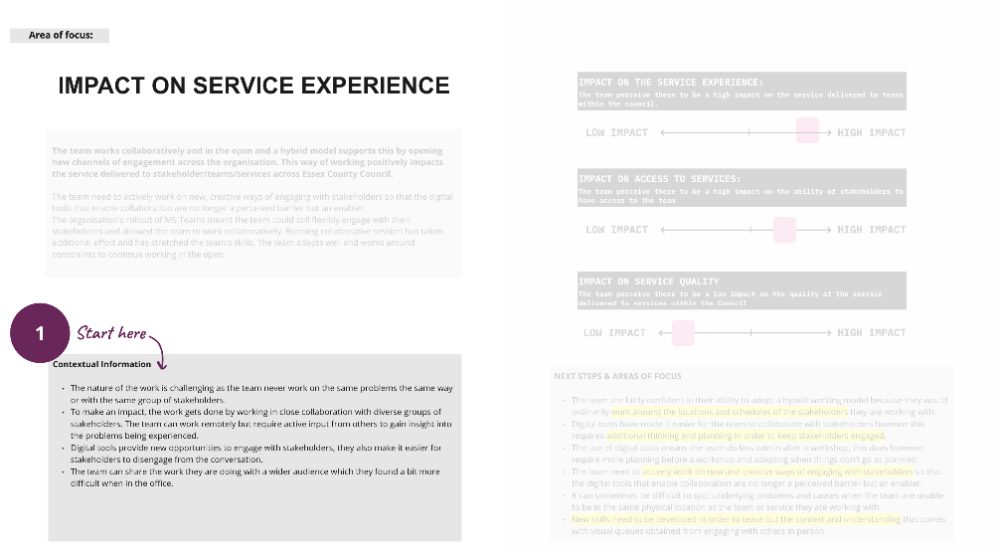

Step 2: Draw out the next steps and areas of focus
Next you will want to summarise the actionable things that came out of your conversation. For each element of the model there will have some actioned things that were discussed – these might be problems (with or without solutions), new ideas or plans for future improvements.
Where positive changes were discussed you may want to double-down on these and suggest further focus. Where issues were discussed with potential solutions you may want to capture these as positive actions. Where pain points were raised you may want to suggest some more focused research or testing to build a more robust evidence base.
It’s useful to think about the short- and longer-term actions that need to be taken, and to highlight the most important areas that need attention.
It’s also a good opportunity to capture who else might need to help to implement and support these next steps.
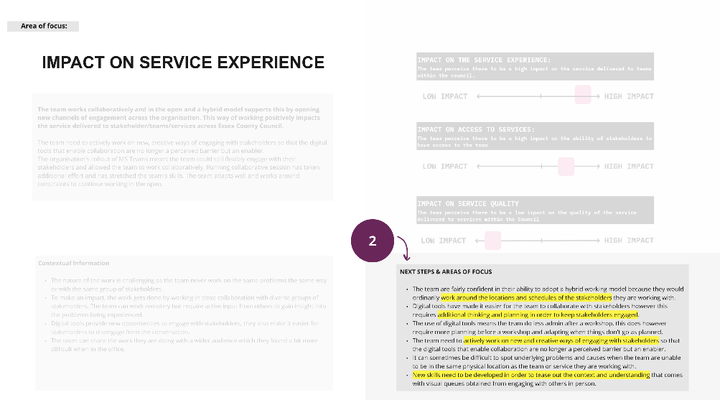

Step 3: Use the contextual information and next steps to generate a short, compelling account of the main impact, tied to the actionable areas of focus.
The as-is model summary will include a lot of rich information. This will be valuable for the team but could be overwhelming for other decision makers.
We’ve found that it’s helpful to pull out the most important or impactful elements from the contextual and actionable information, and to summarise them for each element of the model.
This is also a useful exercise that helps to further synthesize and highlight the most significant impacts that will need to be considered when developing a hybrid working model for the team.
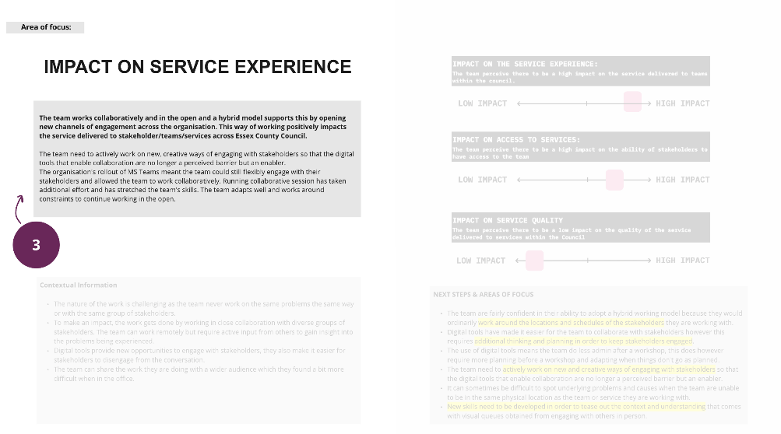

Step 4: Update the sliders so that they reflect the key area that was discussed.
The final step is to update the sliders to visualise the main areas of impact that were discussed. Sliders are a useful visual aid to help teams discuss the impact of change and highlight the things that teams are most concerned or excited about.
The sliders should be adapted to the content that you have captured to show the main areas of positive and negative impact. They can also help to reinforce areas that are more – or less – suited to hybrid working

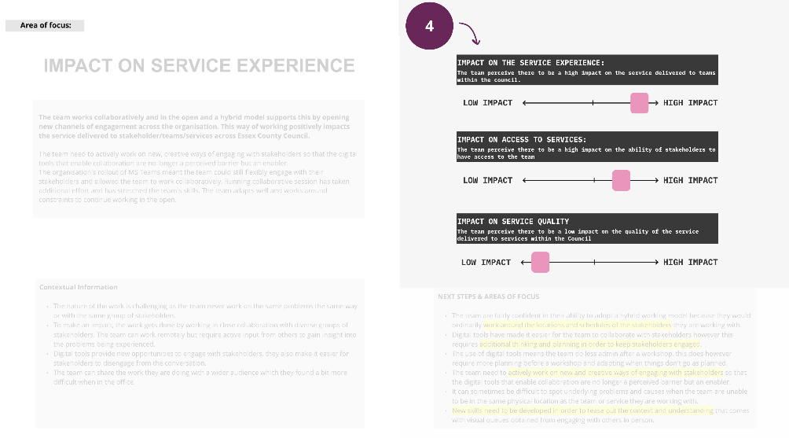

Step 5 – Create an overall summary of the ‘as-is’ model.
In the previous 4 steps we together the main impacts, considerations, and areas of focus for each element of the framework – this should reflect your conversations and be a rich source of useful information for the team.
Across the service experience, people experience and hybrid enablers you may see some clear patterns emerging. The final step is to draw out a model summary from the insights you have captured. By looking across the elements of the model you should be able to draw some conclusions about what’s most important to the team, and the things that will need to be considered when designing their future working models.
This summary can give an indication of what the future ways of working for the team need to be. They can help to articulate how well suited the team is for working from flexible or fixed locations, and at flexible or fixed working times - all supported by evidence and insights from your conversations.
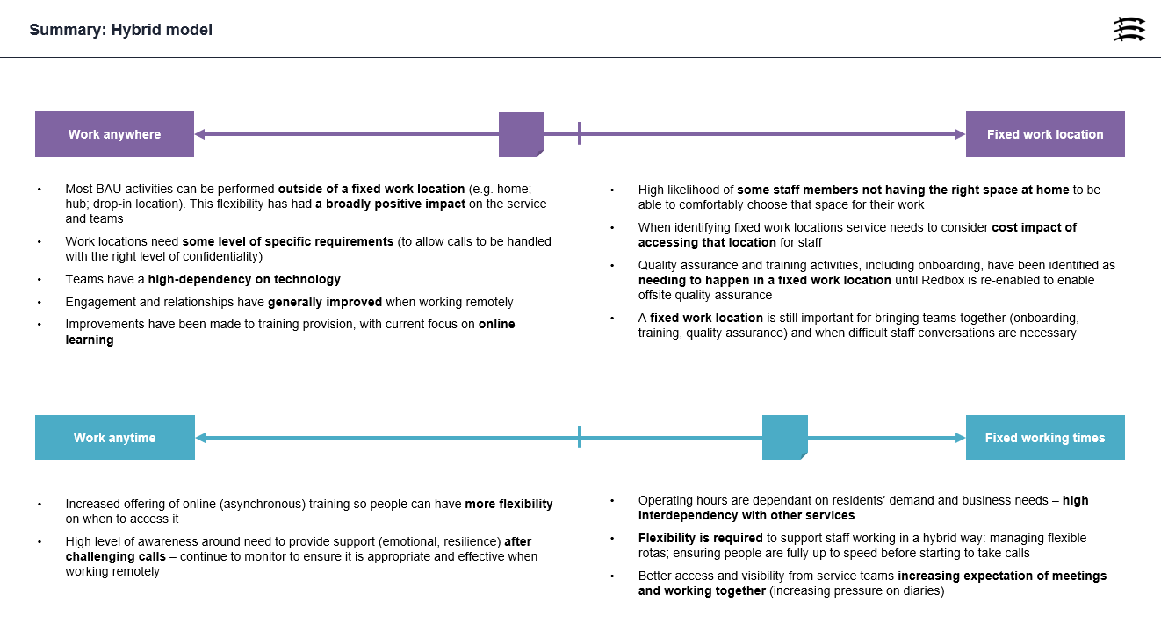

4. Exploration of future models – what comes next?
You have now created an action-oriented summary of where the team are now. This prompts useful conversations around the things that need to change (and stay the same) when designing future working models.
It also creates a great platform from which to ask, ‘what if?’ questions around future ways of working. So, if technology or training issues have been a blocker for the team you can ask ‘what if we fixed that?’ and ‘what would be needed to change this?’. This enables you to explore the potential impact of these changes, and to look beyond what’s happening right now and start to think about the longer-term opportunities
By using a framework to have consistent conversations across teams, you should also start to identify the needs and patterns that are emerging from across the organisation.
These wider insights into the support, resources and tools that team managers and their teams need is the real value that can support good evidence-based decision-making around your future ways of working.

[insert links here]

